CARD 8
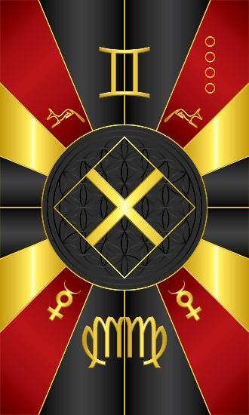
Card 8 represents the energy of Anpu/Eshu or Sebek/Elegba. The main colors are Red, Black, and mixed with some Gold. In the middle is a symbol of the crossroads to which these deities correspond. Although the geometrical symbol is a square, representing the left side of the brain and its functions, when you are traveling down a road and you come to the crossroads, you have 3 new paths from which to choose to traverse. The sacred number associated with these deities is 3.

Above is the symbol for the constellation of Virgo, but stylized for symmetry. Below is the symbol for the constellation of Gemini. In the corners is the astrological glyph for the planet Mercury.

Comments by Baba Awodele

